Joining Vimeo

1) Go to http://vimeo.com/ and click on the “Join Vimeo” button.
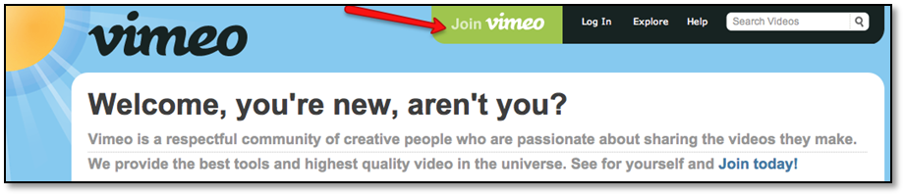
2) Choose “Basic” to start a free account (that’s all you’ll need for this course).

3) Fill in your name, email, and password on the next screen. Check the box to agree to the terms of service, then click “Join Vimeo.” You’ll get an email confirming your membership in a few moments.
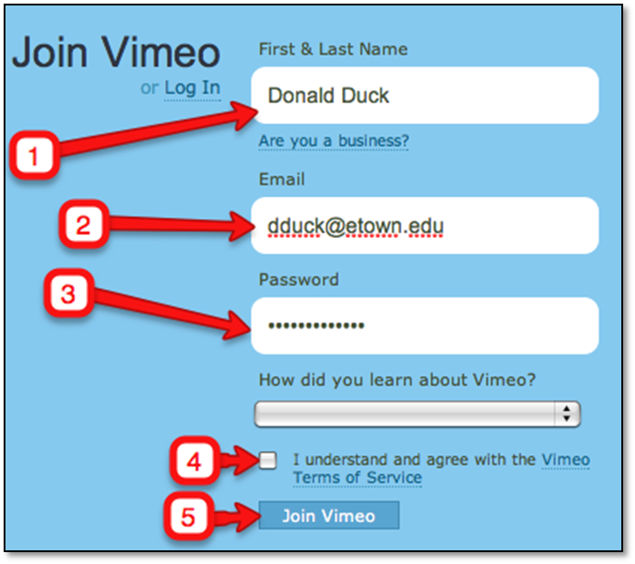

4) You can take the tour, or just close the next window.

5) Click on the “Me” graphic, then select “Settings” from the drop-down menu. 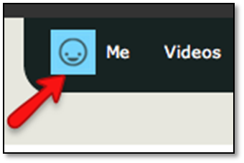
6) Select “Preferences” from the side menu.
- Leave the “Who can see my videos?” field set to “Anyone” (your video is going to be tied to a group, not publicly available).
- Uncheck both boxes under “What can people do with videos?” (this will keep anyone from downloading or sharing your video). Click “Update All Videos” to save this choice!
- Leave the “Who can post comments on videos?” set to “Anyone” (again, it will only be those in our group will know the video is there to comment on).
- You can leave the Creative Commons license area set to “No Creative Commons License.”
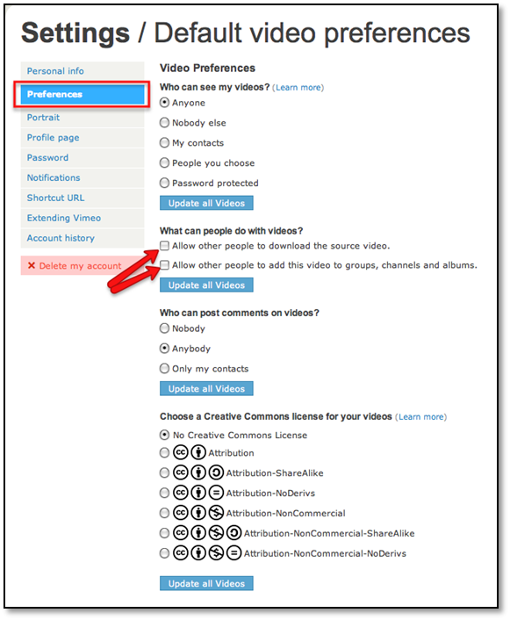
7) You can explore and make other changes if you want to, but the most important thing to do now is email me the first and last name you used for your account. That will permit me to add you to the group and allow you to add your video.

I’ll let you know via email when I’ve added you to the group! Go work on recording your presentation!

When in Vimeo, click the link titled “my videos.” Select the video you want to share. Once the video is selected, directly below you will see a button titled “collections.” Select “collections” and then select the check box for the group titled Elizabethtown College Communications Course and then “download” to download the video the group.

Posting your presentation video

Once you have been added to the group and have recorded your presentation video, follow these instructions for uploading it:

1)Be sure you’re logged in to Vimeo (if you have trouble, be sure you’ve responded to the confirmation email from Vimeo).

2)In the upper menu, click on “Videos” and select “My Groups” from the drop-down menu.


3) On the next screen, choose the Your Class Name Here group.

4) On the main screen for the group, you should see a button on the right to “Upload Video.”
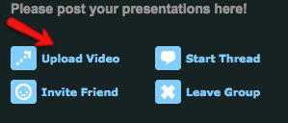
5) On the next screen, click the “Choose a file to upload” button
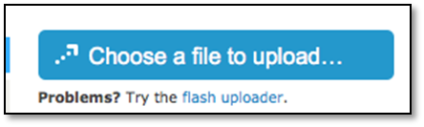
6) Navigate to your presentation video file on your computer, then click “Open.”

7) Your upload should start automatically. Although it may seem quick, the video won’t be ready for others to view until it finishes processing. As that process sometimes takes an hour, Vimeo will just email you when your video is available.

8) Once your video is posted, other class members will be able to view it. Be sure to watch theirs while you’re waiting for yours to finish uploading!

9) To post follow-up questions to each of your classmates, please return to the Blackboard discussion board.

10) Once you’ve read the questions your classmates have submitted to you, please select three (or more) of them to answer in a second video (approximately 10 minutes in length). Once that is recorded, you can follow steps 4-7 above to upload it.
Any questions? Email the ITS Helpdesk at helpdesk@etown.edu !

